HDEV 300 in South Africa (2017)
DRAFT Course Schedule & Itinerary

Mandatory Preparatory Meetings (at CSULB):

Friday, May 19 (2-5pm) Orientation to the study of Death and Dying
Final trip plans

Friday, May 26 (2-5pm) Lecture 1: Western cultural & historical perspectives;
socialization about death.
Lecture 2: South Africa: it’s peoples, a short political history,
customs and manners

Monday evening: May 29 Depart LAX for New York
Tuesday morning: May 30 Depart New York for South Africa

Wednesday: May 31
mid-day: Arrive in Cape Town, South Africa  Settle in, grocery shopping  Overnight: Dale Court self catering apartments  Cape Town – Greenpoint | 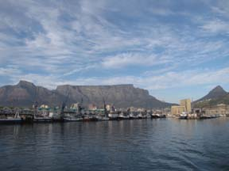

Thursday: June 1

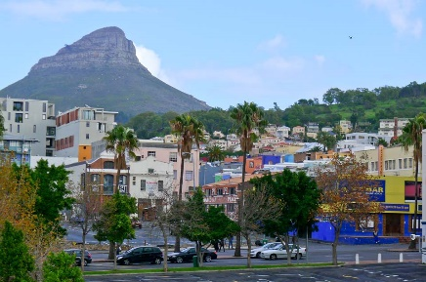 | Morning – late Afternoon: City Tour and  District 6 Museum

THE CITY TOUR
During our orientation tour of the Mother City, we venture through streets crowded with history--from the City Hall where Nelson Mandela gave his liberation speech to the townships outside of Cape Town where the majority lived under apartheid.

HIGHLIGHTS
- Castle of Good Hope  - Parliament buildings  - City Hall  - Bo-Kaap | - District Six Museum  - Signal Hill  - Langa  - Noon Gun
Discover the multicultural history of Cape Town -- from the first European military stronghold in South Africa, to District Six where forced removals tore apart a multiethnic community, to informal settlements where traditional healers and shebeens add to the rich culture of township life.

Our tour is a cross cultural voyage of discovery into the many facets of South African society. This tour encompasses the history of the lives and development of the disadvantaged communities in Cape Town, starting in 1652.

District Six-was once the home of thousands of Capetonians of all hues and cultures. In the 1960’s all were forcibly removed from their homes due to the separate development policy of the apartheid government. District Six residents were then scattered all over the Cape Peninsula (as far from the city center as possible) to areas known as the Cape Flats. On our tour we visit the original site of District Six (now a barren wasteland) as well as the District Museum.

Langa-is the oldest formal township in Cape Town. In Langa you learn about the hostel system that was initiated by the former government to house male migrant workers who came to the city to work but were not allowed to live in the city under apartheid. Now the homes of families, the hostels provide a first view of what township life is like.

On our tour you learn the history of Langa and see the living conditions of thousands of Capetonians who were previously disenfranchised. You also get the sense of the spirit of the ‘New South Africa” that exists here. If we have time, we will also visit a sangoma (a native healer) in Langa.

Evening: grocery shopping

Overnight: Dale Court self catering apartments, Cape Town – Greenpoint

Friday: June 2

Discussion: Logistics
Lecture 1: Development: Lifespan understandings of death
Lecture 2: Working with Children, Special Considerations in South Africa
Evening: Mama Africa’s and other clubs (own account) <optional>
(http://www.mamaafricarest.net/index.htm)

Overnight: Dale Court self catering apartments, Cape Town – Greenpoint

Saturday: June 3

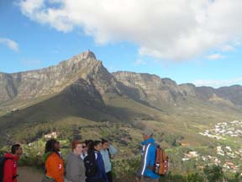 | Lion’s Head hike <optional>  Alternate in wet weather: Kirstenbosch Botanical Gardens  drumming on the streets of Cape Town <optional, weather permitting>

Overnight: Dale Court self catering apartments, Cape Town – Greenpoint

Sunday: June 4

St. Cyprians Anglican Church, Langa—church service and shopping <both optional>

Overnight: Dale Court self catering apartments, Cape Town - Greenpoint

Monday: June 5
Morning: Lecture: Afterlife and the Paranormal  Afternoon: Fieldwork-- Thembani Primary School, Langa | 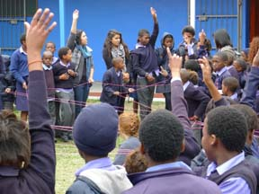

Overnight: Dale Court self catering apartments, Cape Town – Greenpoint

Tuesday: June 6
Morning: Lecture—Xhosa Perspectives 1
Lunch: Learn to Earn, Khayelitsha township
Afternoon: Fieldwork-- Thembani School

Overnight: Dale Court self catering apartments, Cape Town – Greenpoint

Wednesday: June 7
Morning: Lecture-- Caring for the Dying  Late Morning: Philani Development Center  Afternoon: Fieldwork-- Thembani School | 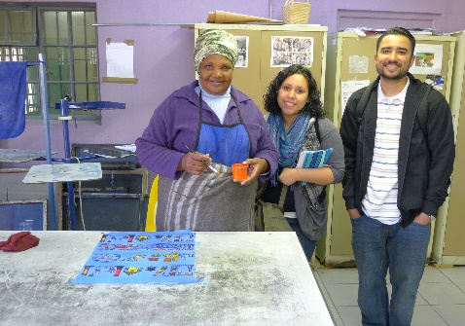

Overnight: Dale Court self catering apartments, Cape Town – Greenpoint

Thursday: June 8

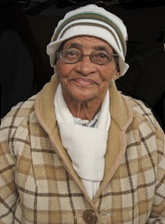 | Morning: Fieldwork-- Rehoboth Age Exchange & G.H. Stark Centres,  Hanover Park  Afternoon: Fieldtrip-- Robben Island  Rehoboth is a center for the aged in Hanover Park, a low income formerly 'coloured' area on the outskirts of Cape Town. Rehoboth provides senior housing, Alzheimer's daycare and hospice care for the elderly. HDEV 300I students will learn about facility and residents through discussions with staff, visiting residents and helping with sports day activities.
Robben Island Ferry Service is the official transport facility to Robben Island for a tour never to be forgotten. These are the state of the art catamarans, fully air conditioned with television sets and a public address system. The Robben Island's tour includes a visit to the lime quarry, a place where prisoners were forced to work in extremely difficult conditions and which led  most prisoners to have a lifelong sensitivity to bright lights. However, the  quarry has it's positive aspects; as the only place where prisoners could discuss their plans for the new South Africa, many call it the first South African Parliament. A visit to the maximum-security prison, home to Nelson Mandela for many years, is one of the important highlights of the tour on Robben Island. This section includes the single cells in which Nelson Mandela and other prisoners spent their prison time.  Other highlights include the tour guides themselves, all of whom were political prisoners at Robben Island, and seeing the house in which Robert Sobukwe, the first President of the Pan Africanist Congress, was held. |  | 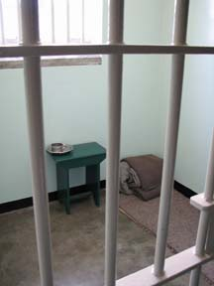  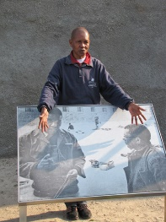
Overnight: Dale Court self catering apartments, Cape Town - Greenpoint

Friday: June 9

Morning: Fieldwork-- Rehoboth Age Exchange & G.H. Stark Centres
Guest Lecture: Hospice work
Afternoon: Lecture-- Personal Death

Overnight: Dale Court self catering apartments, Cape Town – Greenpoint
<Optional stay in township B&B>

Saturday: June 10
All day: Cape Peninsula tour  <optional> | 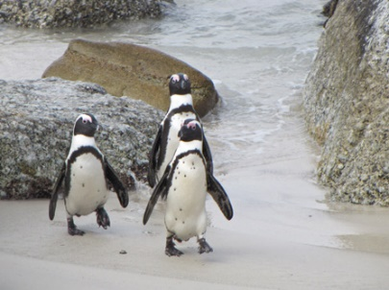 | 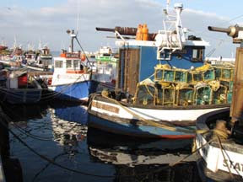

View the golden beaches of Camps Bay and Clifton, home of South Africa’s elite.

We stop at the quaint fishing village of Hout Bay where local fisherman still go out everyday in little fishing boats to feed their families hoping for a big catch. From there we go via Chapman’s Peak sandwiched between the ravaging ocean and looming mountain cliffs via the scenic artist village called Noordhoek en route to the Cape of Good Hope Nature Reserve – home to a rich diversity of plant and animal life, including baboons and wild ostriches.

We spend some time at Cape Point - There is some debate as to whether or not this is where the two oceans meet. Some people believe the Indian and Atlantic Oceans meet at the southern most point of Africa, Cape Agulhas, about 200km East of Cape Town, while others think it is here at Cape Point on the Cape Peninsula.

We then proceed via enchanting False Bay Coast line paying a visit to some penguins and land based Penguin Colony and then onto historical Simonstown and Kalk Bay. Walk about in this multicultural fishing village interacting with the fisherman and learning more about the lives of the fishermen and their families, their history and culture.

Overnight: Dale Court self catering apartments, Cape Town - Greenpoint

Sunday: June 11

Free day

Overnight: Dale Court self catering apartments, Cape Town – Greenpoint

Monday: June 12
Morning: Lecture—Bereavement & Ritual1  Late Morning: Fieldtrip to Cape Town cemeteries, crematorium  Afternoon: Fieldwork—Thembani School (last day)  Overnight: Dale Court self catering apartments,  Cape Town - Greenpoint | 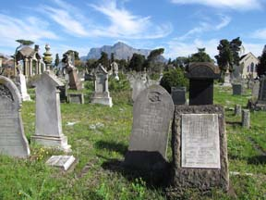

Tuesday: June 13

Early Morning: Leave for Johannesburg  Afternoon: Apartheid Museum  Late Afternoon: Discussion of fieldtrip and readings  Apartheid Museum  At times you feel overwhelmed by the screens and sound and  the powerful images they are projecting. The Museum leads  you through room after room in a zigzag of shapes, some with | 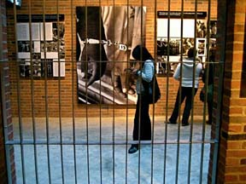
tall roofs, some dark and gloomy, some looking through to other
images behind bars or cages that make it clear that apartheid was not only immoral, but evil.

AFTER a few hours at the Apartheid Museum you will feel that you were in the townships in the 70s and
80s, dodging police bullets or teargas canisters, or marching and toy-toying with thousands of school
children, or carrying the body of a comrade into a nearby house. And just when you feel you can't
tolerate the bombardment of your senses any longer, you reach a quiet space, with a glass case which
contains a book of the new Constitution of South Africa, and pebbles on the floor. You can express your
solidarity with the victims of apartheid by placing your own pebble on a pile, and take a book. You'll then
walk out into grassland with paths which take you to a small lake - you'll need this reflective time.

Overnight: Airport Grand Hotel, Johannesburg (http://www.airportgrand.co.za/)

Wednesday: June 14
All day: Fieldtrip-- Soweto (including Hector Pieterson Museum,  Walter Sissulu Square, Regina Mundi  Catholic Church, Avalon cemetery)  Late Lunch at Wandies - Soweto  Early evening: Class discussion of fieldtrip and readings | 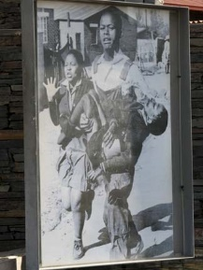

Hector Pieterson Museum
The Hector Pieterson Museum opened on Youth Day, 16 June, but don't expect to come away with an image of what Hector looked like - the family do not have a single snapshot of their famous son. Hector, 12, was one of the first casualties of the Soweto uprising of 16 June, 1976, when over 500 children were killed as they protested over the imposition of Afrikaans as a medium of instruction in township schools. A news photograph of the dying Hector being carried by a fellow student was published around the world.

The museum named after Hector commemorates the youth movement that led to the loss of so many young lives and that finally focused the attention of the world on the evils of apartheid. This museum represents a relatively recent community struggle and ultimate victory, a message made more poignant by the fact that Antoinette Sithole, Hector's sister who is seen crying by his side in the famous photograph, often works at the museum herself.

You will also visit Regina Mundi Catholic Church, the safe haven for many of the protestors in the Soweto uprisings, and Walter Sissulu Square, the site where the Freedom Charter (which outlined core principles underlying the current South African constitution) was adopted in 1955.

Overnight: Airport Grand Hotel, Johannesburg (http://www.airportgrand.co.za/)

Thursday: June 15

Kwandebele village

Lunch at village

Evening: Discussion of fieldtrip and fieldwork

Kwandebele Village  In present day South Africa, the Ndebele people are well known for their elaborately painted houses, intricate bead work and, when they choose to wear it, the colorful traditional dress of Ndebele women. | 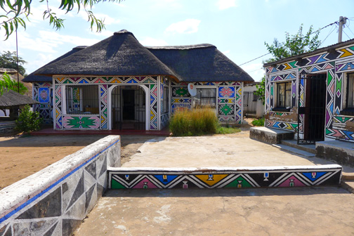 | 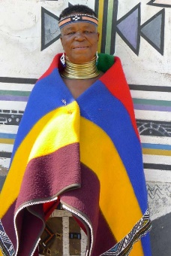

Overnight: Airport Grand Hotel, Johannesburg (http://www.airportgrand.co.za/)

Friday: June 16

Early Morning: Youth Day March in Soweto  Afternoon: Fieldtrip-- Constitution Hill  Evening: Discussion of fieldtrip and readings | 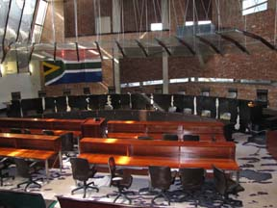
Constitution Hill
Once the site of infamous men's and women's prisons, the tour of Constitution Hill incorporates the old and the new, detailing the treatment of prisoners under apartheid and the Constitutional Court which ensures that those brutalities will never happen again.

Overnight: Airport Grand Hotel, Johannesburg (http://www.airportgrand.co.za/)

Saturday, June 17
Early morning: Leave for Kruger Park
Sunset and early evening: game drive
Depart early morning to drive in an air-conditioned vehicle to Tremisana Game Lodge in the Balule section of the Kruger National Park. After a short break, during which you can unwind and enjoy a quick swim, we board an open Land cruiser for a Sunset Drive. After dark, your ranger will use a powerful spotlight to identify nocturnal animals. Dinner in the Boma will be a traditional South African meal. Overnight in comfortable, en suite thatch-roofed chalets.
Overnight: Tremisana Game Lodge, Viva Safaris
(http://www.vivasafaris.com/safaristremisanalodge.php)

Sunday: June 18

Safari
all day

After breakfast, we depart for the Orpen Gate of Kruger Park. From your open Game viewer you are afforded an outstanding opportunity to fully experience Africa's wild animals. The elevated vantage position and absence of glass windows allow for truly unforgettable sight, sound and scent experiences and brilliant photographic opportunities. Spend the full day game-viewing and bird-watching in the company of a knowledgeable guide. Spend the evening in your thatched cottage with the sounds of the African night to lull you to sleep.

Overnight: Tremisana Game Lodge, Viva Safaris
(http://www.vivasafaris.com/safaristremisanalodge.php

Monday: June 19
Morning: Fieldwork with Funjwa Primary School

Afternoon: Panorama Route

Early Evening: Lecture/Discussion: Ritual 2

Some of the most beautiful scenery in Mpumalanga is on the Panorama Route, especially Blyde Canyon, the Three Rondavels and The Potholes. We spend the afternoon visiting them—contemplating the views and sitting by the waterfalls.

Overnight: Tremisana Game Lodge, Viva Safaris

Tuesday: June 20

Morning: Fieldwork with Funjwa Primary School

Afternoon: Free time or short safari or
cheetah rescue <own account>

Evening: Discussion of Death, Dying & Living in
South Africa today

Overnight: Tremisana Game Lodge
Viva Safaris

Wednesday: June 21

Early morning: Leave Tremisana for Johannesburg

Early evening: Depart Johannesburg for U.S.

Thursday: June 22

Afternoon: Arrive LAX

