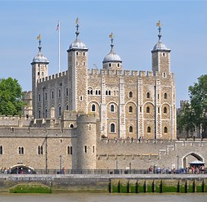
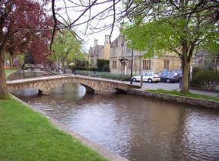
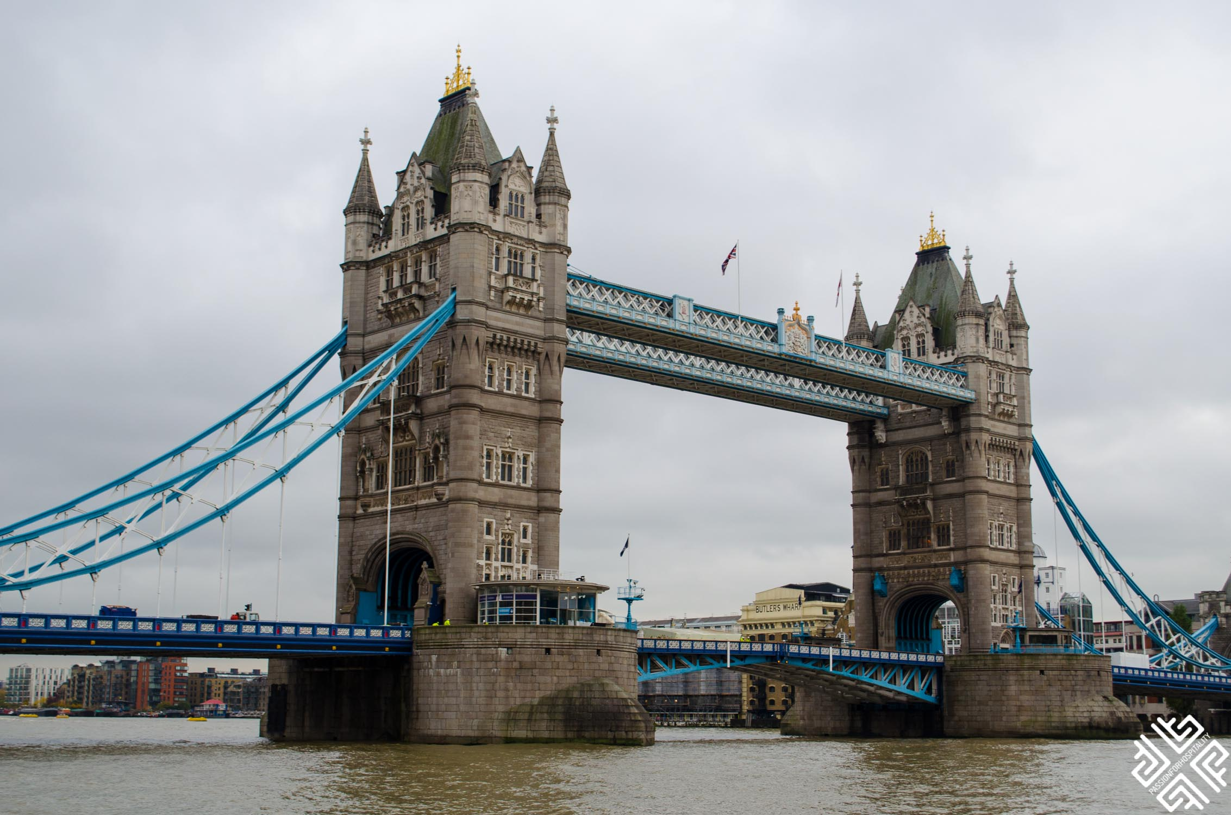

ENROLL IN A 4-WEEK STUDY-ABROAD PROGRAM TO

VISIT ENGLAND AND SCOTLAND IN THE SUMMER

OF 2018 (June 4th to July 3rd)
Total Cost for the 4 Weeks: Approximately $5,200.00 (this includes air fare, CSULB summer tuition fees, medical insurance, travel within London, England, and Scotland, lodging for 30 days, 28 breakfasts, some dinners and some lunches, and the following activities in London and in Scotland.
EXPLORE THE HISTORY AND CULTURE OF ENGLAND AND THE TRANQUILITY AND BEAUTY OF SCOTLAND.
LEARN AND EARN ACADEMIC CREDIT.
Some Highlights of the Itinerary Include

- Unlimited use of Oyster Card (tube card) for the Duration of a Month
- 26 Nights in Beautiful London
- 4 Nights in Scotland
________________________
Travel deposit for the program, can be paid by check, credit card, or cash to the College of Continuing and Professional Education (CCPE). CCPE is located in the Foundation Building and is open M-F from 8:00 a.m. to 5:00 p.m. The deposit fees can also be paid via telephone--: (562) 985-5561. The dates when the installments have to be paid will be announced to the students.

SUMMER SESSION I: June 1 to July 2nd 2018
- Tower Bridge
- Boat Ride on the River Thames
- Visit the Houses of Parliament
- Visit the Harrods Department Store
- Visit Selfridges
- Visit Windsor Castle
- Visit Hampton Court
- Visit Westminster Abbey
- Visit Buckingham Palace
- 3 Walking Tours in London
- City Tour of London
- Big Ben
- Tower of London
- Museum of London
- Geffrye Museum
- Foundling Museum
- Sir James Soane’s Home & Museum
- National Art Gallery
- Tate Gallery
- Globe Theater
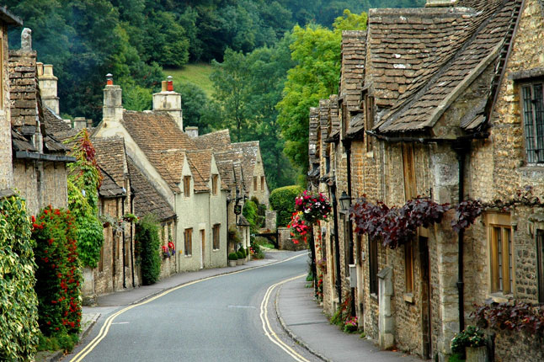
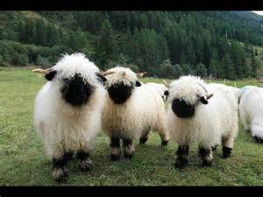

Don’t Miss this Wonderful Opportunity!
Travel, Learn, and Earn University Credits

HIGHLIGHTS OF SOME OTHER EXCURIONS THAT ARE INCLUDED
IN THE COURSE

- Visit to Stonehenge
- Tour of the Parliament
- Visit to Bath
- Theater Performance in London
- Visit to Oxford
- Several Local Guest Speakers
- Visit an Elite Upper Class School
- Tour of Edinburgh and the Highlands
- Visit Markets in London
- Visit to St. Andrews
- Visits to Social Service Agencies & NGOS
- Visit to Cotswolds

Learn about the history, culture, immigration patterns, challenges, diversity, laws affecting
children, and families in England, and Scotland.

Take the FCS 490D: Children and Families in the Community: A Comparative
Study Between the U.S., England, and Scotland (3 Units) course.

Substitute Study Abroad Course For One of the Following Courses:
FCS 497: Independent Study (3 Units)
UNIV 301: Global Studies (3 Units)
CDFS 410: International Families OR
Substitute the Study Abroad Course for any Elective in Your Major
Contact Information:
Professor: Dr. Nilufer Medora
Department of Family and Consumer Science (Opposite Brotman Hall)
FCS-101: (562)985-4488
Medora@csulb.edu SUMMER SESSION I: June 4th to July 3rd 2018

